Software Requirements Specification

for

EDU Games

Version 1.0 approved

Prepared by  
Minh Khoi Phan  
Angelica Cuadrado  
Shane Duffney  
Drake Kirkos

12/04/2024

Table of Contents

Table of Contents ii

Revision History ii

1. Introduction 1

1.1 Purpose 1

1.2 Document Conventions 1

1.3 Intended Audience and Reading Suggestions 1

1.4 Product Scope 1

1.5 References 1

2. Overall Description 2

2.1 Product Perspective 2

2.2 Product Functions 2

2.3 User Classes and Characteristics 2

2.4 Operating Environment 2

2.5 Design and Implementation Constraints 2

2.6 User Documentation 2

2.7 Assumptions and Dependencies 3

3. External Interface Requirements 3

3.1 User Interfaces 3

3.2 Hardware Interfaces 3

3.3 Software Interfaces 3

3.4 Communications Interfaces 3

4. System Features 4

4.1 System Feature 1 4

4.2 System Feature 2 (and so on) 4

5. Other Nonfunctional Requirements 4

5.1 Performance Requirements 4

5.2 Safety Requirements 5

5.3 Security Requirements 5

5.4 Software Quality Attributes 5

5.5 Business Rules 5

6. Other Requirements 5

Appendix A: Glossary 5

Appendix B: Analysis Models 5

Appendix C: To Be Determined List 6

Revision History

|  |  |  |  |
| --- | --- | --- | --- |
| **Name** | **Date** | **Reason For Changes** | **Version** |
|  |  |  |  |
|  |  |  |  |

# Introduction

## Purpose

This software is an educational gaming platform for students and kids to relax, learn and have fun at the same time. This software will invent a new way to support children’s learning ability with subject personalization and controls from adults.

## Document Conventions

|  |  |
| --- | --- |
| **Acronyms** | **Description** |
| EDU | Educational |
| DB | Database |
| HTML | HyperText Markup Language |
| C# | C Sharp Programming Language |
| API | Application Programming Interface |
| IT | Information Technology |
| DEV | Developer |

## Intended Audience and Reading Suggestions

Audience: Students, kids, parents, school managers/faculty, game developers, marketing Managers, investors, IT Administrators

## Product Scope

Besides learning from textbooks, EDU Games provides students a platform with multiple mini-games which vary in many subjects and are in accordance with students' grade level. Students can play at school, in-class or at home. Students access EDU Games via subscription, when sign up they’re required to update appropriate documents to verify their student status (grade level, school, subject of interest…). The platform will only show appropriate games to each specific student based on their status and permission from parents/school faculty. Once games are played, the system will keep track of the students’ scores/results, displaying them on a ranking table and giving rewards accordingly.

Listing of scope ideas:

* Supports 3rd party developers to make and produce games. (reviewed before publication)
* A personal subscription where a parent can select their child's grade and class, which will then affect them.
* Games are categorized into multiple difficulty levels. Once a student master 1 level, the system/parents/teachers will add new games at higher difficulty level
* Parents/teachers can choose to have a system automatically progress games, or manually control them to limit the number of games a child can play within a day/week.
* Partnership with schools
* Teachers can review a student's progress
* Multiple subjects for the children
* Virtual trophies that are unlocked
* On student accounts students can view the highest scores of their fellow students to encourage them to do better.
* Virtual Trophy Display, connect with social media.

**Available game subjects:**

Math, English, Physics, Chemistry.

## References

Raouna, K. (2023, December 22). 30 Best Online Learning Platforms for 2024. LearnWorlds.

<https://www.learnworlds.com/online-learning-platforms/>

AdaptedMind.

<https://www.adaptedmind.com/next/lp/plato-signup?utm_medium=cpc&utm_source=google&campaignid=19815638762&campaign_type=search&placement=g&utm_content=responsivesearchad&adid=651121338607&adset_id=149849668071&utm_term=online+education+games&ad_position=&device=c&gad_source=1&gclid=EAIaIQobChMItcCK4ObpgwMVuzrUAR2f6g8LEAAYASAAEgK7ZvD_BwE>

CBC Kids.

<https://www.cbc.ca/kids/games>

Shah, S. (2023, November 3). How to avoid the dangers of Online Gaming Platforms: A guide for Reponsible Gamers.

<https://www.linkedin.com/pulse/how-avoid-dangers-online-gaming-platforms-guide-responsible-shah-oo0uf?trk=article-ssr-frontend-pulse_more-articles_related-content-card#:~:text=Another%20risk%20is%20fraud.,personal%20information%20than%20they%20should>.

Brainfuse. (2022, February 8). Brainfuse online tutoring, homework help, resume review, and much more. Brainfuse Online Tutoring.

<https://home.brainfuse.com/>

Science Games and Videos | Educational games for kids. (n.d.). NeoK12. <https://www.neok12.com/>

IXL | Math and English Language Arts Practice. (n.d.). IXL Learning. <https://ca.ixl.com/?partner=google&campaign=71592328&adGroup=129630692767&gclid=EAIaIQobChMIvenIhcf7gwMVnSitBh3R-QedEAAYASAAEgIpz_D_BwE>

# Overall Description

## Product Perspective

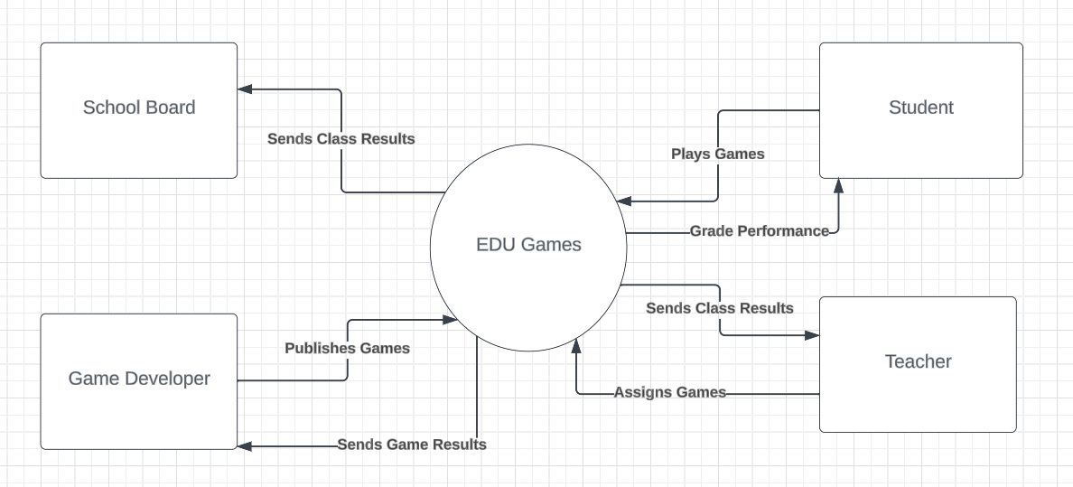EDU Games is a new, self-contained product that aims to provide an innovative and enjoyable way of learning for students and kids. It is not a replacement or a follow-on of any existing system, but rather a novel approach to support children’s learning ability with subject personalization and controls from adults. EDU Games is a web-based platform that can be accessed through any browser and device. It does not require any installation or configuration on the user’s side. It interacts with other systems and applications through APIs and web services, such as authentication, payment, and analytics.

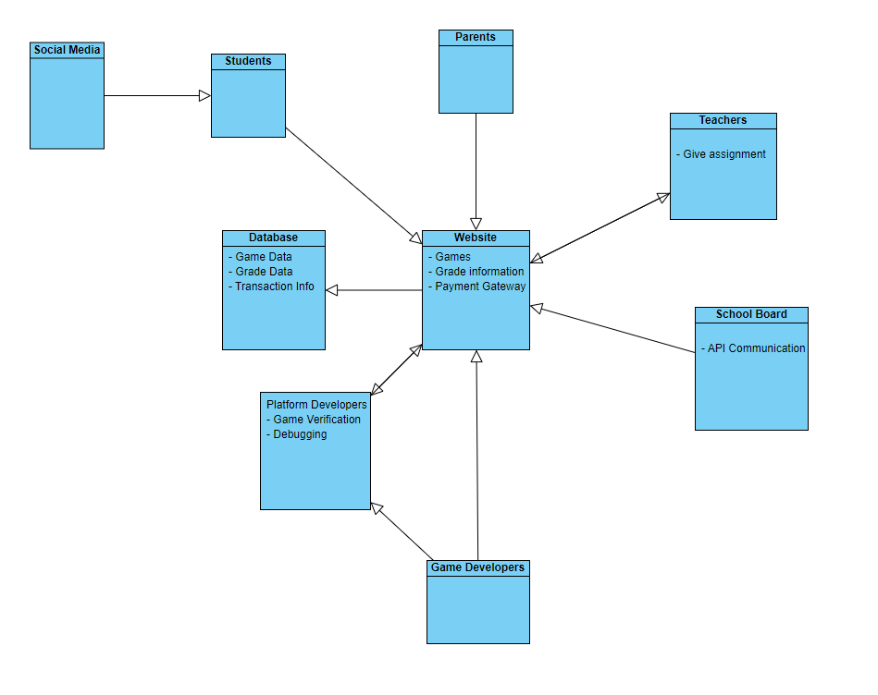

## Product Functions

* Collect and store information about students.
* Store information about users’ payment.
* Filter suitable games in accordance with students’ status, permission.
* Parental Control.
* Adaptive Learning.
* Collaborative Learning: Multiplayer games, Grouping/Teaming up students.
* Reward System with virtual badges/medals for motivation.
* Customizable Achievement Display.
* Social media connectivity to show achievements.
* Have regular new games and updates.
* Connect to Wi-Fi.
* Connect to school API for login.

## User Classes and Characteristics

**Students:** The primary audience for this software is students of all ages who are looking for an engaging and fun way to learn and consolidate what they’ve learned from school. EDU Games provides a platform with multiple mini games that vary in many subjects and are in accordance with students’ grade levels.

**Parents:** Parents are another key audience for EDU Games. They can use the platform to monitor their children’s progress, set goals, and provide feedback to teachers. Parents can also use the platform to help their children learn and reinforce what they’ve learned in school.

**School Managers/Faculty:** School managers and faculty can use EDU Games to supplement their existing curriculum and provide students with an additional learning resource. They can also use the platform to monitor student progress and identify areas where additional support may be needed.

**Marketing Managers**: Marketing managers can use EDU Games to promote the platform and reach out to potential customers. They can also use the platform to gather feedback from users and improve their marketing strategy.

**Investors:** Investors can use EDU Games to evaluate the platform's potential and make informed decisions about funding. They can also use the platform to monitor the progress of the project and ensure that it is on track to meet its goals.

**IT Administrators:** IT administrators can use EDU Games to manage the technical aspects of the platform, including security, performance, and scalability. They can also use the platform to monitor usage patterns and identify areas for improvement.

## Operating Environment

* Will run on a web server that supports ASP.NET Core 5.0 or higher
* Will use HTML, CSS, and JavaScript for the front-end development
* Will use OracleDB and jQuery as the main front-end libraries
* Will use Visual Studio 2022 or later as the main development tool
* Will use Swagger for API documentation and Postman for API testing

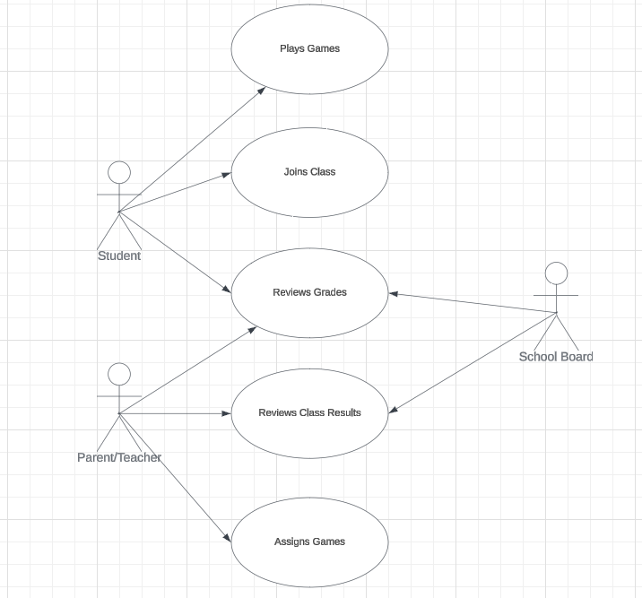

## Assumptions and Dependencies

* EDU Games assumes and depends on the involvement of qualified professionals, such as teachers, educators, or subject matter experts, who can review and approve the content in the games.
* EDU Games team expects these professionals to be available, willing, and able to collaborate with the game developers and provide timely feedback and suggestions.
* EDU Games team also relies on these professionals to ensure that the content in the games is accurate, appropriate, and aligned with the learning objectives and standards, and to avoid any malicious content or fallacies that may harm or mislead the students or damage the reputation of the platform.

# External Interface Requirements

## User Interfaces

EDU Games, our innovative educational platform, is designed with a responsive interface that adapts seamlessly to any device, from desktop computers to tablets and smartphones. It is compatible with all major browsers, including Google Chrome, Mozilla Firefox, Safari, and Microsoft Edge, ensuring accessibility for all users.

Students can easily access EDU Games via their preferred browser, such as Chrome, and log in using their unique student account credentials. Once logged in, they can explore a wide range of educational games tailored to their learning needs.

Parents, school managers, and faculty members have the ability to log in via their specialized admin accounts. This grants them access to an additional admin tab, where they can manage various aspects of the platform, monitor student progress, and customize the learning experience.

Game Developers also have a dedicated portal, accessible via their developer accounts. This portal allows them to manage their games, update content, and collect valuable data related to game usage and performance. This data can be used to continually improve the games and ensure they are effectively engaging and educating the students.

## Hardware Interfaces

**Keyboard:** Essential for text input and navigation within the platform.

**Mouse:** Facilitates easy navigation and selection within the platform.

**Touchscreen Devices (Optional):** Mobiles and tablets provide a more interactive experience with touch-based navigation.

## Software Interfaces

**Payment Gateway:** A secure and reliable payment gateway is integrated for processing subscription payments.

**School Login Interface**: A dedicated login interface for schools allows for easy management and tracking of student progress.

**Game Developer Portal(Future):** A specialized portal for game developers to manage and update their games.

**Admin Panel:** A comprehensive panel for administrators to manage the platform and monitor user activity.

## Use cases

Our platform, EDU Games, is designed to provide a comprehensive and engaging educational experience. It offers a variety of use cases tailored to the needs of different users:

|  |  |  |  |
| --- | --- | --- | --- |
| **Use cases** | | | |
| **Use Case name** | **Req. ID** | **Actor (s)** | **Brief Description** |
| Track Performance | FR01FR13 | StudentsParents Teachers | When the students start with any game, the platform will automatically record the playtime of the student while using the application.  This information will be available to the parents and teachers; the students can also access this recorder if they need feedback. |
| Manage Trophies | FR02FR03  FR05 | Students | The students after logging in will see an option on the main screen called “Trophies”, this section will empower the students to manage their facilitated Trophies. Here they can create, update, view the status of, claim or share. |
| Trophy Posting | FR02 | Students | The students can easily post their accomplishments, badges, or milestones on authorized social media |
| Create groups of students | FR04 | Teachers | The teachers after logging in will see a tab called “Classes” containing a list of all classes they manage. Clicking on one of the classes will show them all the students in that class. There is a button to create groups and add students into them. |
| Navigate the platform as students | FR05 | Students | Students, after logging in will see a tab called “Evaluations.” Selecting this tab will bring the students to a page containing all their completed games/assignments. Selecting one of these assignments will allow the student to see the grade they have previously attained. Students will also see any previously achieved grades before starting a game. |
| Navigate the platform as teachers | FR05 | Teachers | The teachers after logging as admin will see a tab called “Classes” which when clicked will bring them to a page containing a list of all classes they manage. Clicking on one of the classes will show them all the students in that class. Clicking on that student will show information about that student including all Games/Assignments completed by the student. Clicking on any of the assignments will allow the actor to see the grade achieved by that student or set grades manually if needed. |
| Navigate the platform as parents | FR06 | Parents | The parents after logging will see a tab called “Student Activities” which when clicked will bring them to a page containing the detailed information of the student associated with the parent’s account such as playtime, scores, grades, assigned games. Parents can also adjust the allowed playtime of the associated student with a slider. |
| Navigate the platform as School Board | FR09FR15 | Principle | The principle after logging will see a tab called “Student Activities” which when clicked will bring them to a page containing the detailed information of all the classes and students. There is also a button to reward a student with virtual badges/medals/certificates according to their performance. |
| Login account | FR10 | Students  Teachers  Parents | Students, teachers and parents upon entering the website will be prompted with a screen asking for the user’s login information, or the option to make an account. On this screen, if the user is logging in, they will need to enter their email/username and the password they have chosen for their account. After entering their information into the text boxes, the user will then be logged in to the main website |
| Reset Password | FR11 | Students Teachers  Parents | If the user has forgotten their password information to their account, they will also be given the option to reset their password on the user login screen. If the user clicks “reset password” they will be brought to a new page prompting the user to enter their email. After entering their email and clicking submit, the user will be sent an email with another link to a password reset page. Here the user will enter their new password twice and click submit. After doing this their account will be given their new chosen password |
| Remove Account | FR12 | Principle | If the principle wishes to remove an account from their school when a student drops out of the school or has a duplicate/fake account. |

## Communications Interfaces

EDU Games, as a comprehensive educational platform, requires robust and secure communication interfaces to ensure seamless interaction between users and the system. Here are the key requirements:

* **Email Communications:** The platform should support email notifications for account creation, password resets, updates, and other important notifications. Emails should be formatted properly to ensure readability and should adhere to standard email protocols.
* **Web Browser Compatibility:** The platform should be compatible with all major web browsers, including Google Chrome, Mozilla Firefox, Safari, and Microsoft Edge. This ensures that users can access the platform from any device.
* **Network Server Communications Protocols:** The platform should use standard communication protocols such as HTTP/HTTPS for web traffic and FTP/SFTP for file transfers. This ensures interoperability and compatibility with various systems and devices.
* **Electronic Forms**: The platform should support electronic forms for user registration, profile updates, and other data collection needs. These forms should be designed with user-friendly interfaces and should validate user input to prevent errors and security issues.
* **Communication Standards:** The platform should adhere to standard communication protocols such as HTTP for web traffic, SMTP for email communications, and FTP for file transfers. This ensures seamless and efficient communication between the platform and the users.
* **Communication Security and Encryption:** All communications should be encrypted using standard encryption techniques such as SSL/TLS to ensure data privacy and security. This is particularly important for sensitive data such as user credentials and personal information.
* **Data Transfer Rates:** The platform should support high data transfer rates to ensure fast and efficient access to educational games and other resources. This is crucial for providing a smooth and lag-free user experience.
* **Synchronization Mechanisms:** The platform should support real-time synchronization to ensure that user data is always up-to-date across all devices. This includes game progress, scores, and other user-specific data.

# System Features

## Functional Requirements

Our platform, EDU Games, is designed with a diverse set of functional requirements to cater to the needs of various users:

|  |  |  |  |  |
| --- | --- | --- | --- | --- |
| **Functional Requirements List** | | | | |
| **Req.ID** | **Requirement Title** | **Short Description** | **Priority** | **Requester** |
| FR01 | Achievement Management | Allow students to manage their achievements. | high | Students |
| FR02 | Achievement Posting | Facilitate students to post their achievements on social media | normal | Students |
| FR03 | Users Grouping | Teachers should be able to group students together for game assignments. | normal | Teacher |
| FR04 | Student Level Access | Allow students to view filtered/assigned games, their own scores and peer’s performance. | high | Students |
| FR05 | Teacher Level Access | Allow teachers to assign games as homework/assignments to student | high | Teacher |
| FR06 | Parent Level Access | Allow parents to limit students’ playing time on the platform | high | Parents |
| FR07 | Game Authorization | Allow certified professionals to authorize requested games and game content that will be added to the platform | high | Parents  School board |
| FR09 | High Level Access | Allow accounts with high level such as parent, teacher, school board to view student’s playtime, scores and performance for assessment. | high | Teacher, Parents, School Board |
| FR10 | User login | The platform allows users to create an account and log in securely. | high | IT Administrator |
| FR11 | User Password Reset | The system also provides password reset mechanism in case the user forgets their password. | high | IT Administrator |
| FR12 | User Removal | The system will remove invalid accounts e.g. a student drops out of school. | high | IT Administrator |
| FR13 | Progress tracking | Track the student’s scores and progress | high | Parents  Teachers  School board |
| FR14 | Achievement Reward System | Award students’ high scores and performance with virtual badges/medals accordingly | high | Students  Parents  Teachers |
| FR15 | Achievement Customization | Allow students to edit the appearance of their achievement display. | normal | Students |

## Swimlane Diagram

## Use Case Diagram

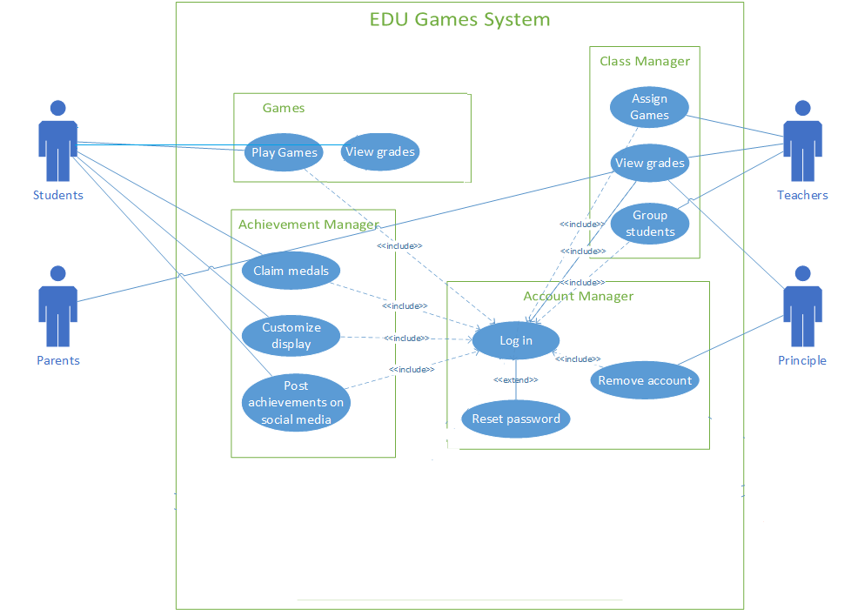

# Other Nonfunctional Requirements

## Performance, Safety, Security and Software Requirements

|  |  |  |  |  |
| --- | --- | --- | --- | --- |
| **Nonfunctional Requirements List** | | | | |
| **Requirement ID** | **Requirement Title** | **Short Description** | **Priority** | **Requester** |
| NFR01 | Availability | The system must be available 24/7 | High | IT Administrator |
| NFR02 | Data integrity | The system must encrypt all customers' credit cards numbers when handling subscription. | High | IT security officer |
| NFR03 | Browser compatibility | The system should be able to run on Chrome and Firefox | High | School board director |
| NFR04 | User limit warning | The system should send a warning if it is consistently handling more than 70% of its total possible current users. | Normal | IT Administrator |
| NFR05 | Cyber security | Prevent unauthorized users from posting games/changing stats | High | IT security officer |
| NFR06 | Performance | The platform should be able to handle 5000 games at a time without any delay from the servers | Normal | student |
| NFR07 | Accessibility | The platform should be accessible to users with color-blind disability. | Low | Parents  Teachers  Students |

# Other Requirements

In addition to the functional and system requirements, there are several other requirements that need to be considered for the EDU Games platform:

* **Database Requirements**: The platform should have a robust and secure database to store user information, game data, scores, achievements, and other relevant data. The database should support efficient data retrieval and updates to ensure a smooth user experience.
* **Internationalization Requirements**: The platform should support multiple languages to cater to a global user base. This includes language translation for the user interface, support for different date and time formats, and other localization features.
* **Legal Requirements**: The platform should comply with all applicable laws and regulations, including data privacy laws, copyright laws, and educational standards. This includes obtaining necessary permissions and consents for data collection and use.
* **Reuse Objectives**: The platform should be designed with modularity and reusability in mind. This includes using reusable components, following coding standards and best practices, and maintaining a clean and maintainable codebase.

# Appendix A: Glossary

* **FR**: Functional Requirement
* **SRS**: Software Requirements Specification
* **UI**: User Interface
* **HTTP**: Hypertext Transfer Protocol
* **HTTPS**: Hypertext Transfer Protocol Secure
* **FTP**: File Transfer Protocol
* **SFTP**: SSH File Transfer Protocol
* **SSL/TLS**: Secure Sockets Layer/Transport Layer Security
* **SMTP**: Simple Mail Transfer Protocol

This glossary provides definitions for acronyms and abbreviations used in this SRS. It helps ensure clear and consistent understanding of the terms used in the document. For terms used across multiple projects or the entire organization, a separate, comprehensive glossary may be maintained.

Appendix C: To Be Determined List

|  |  |  |  |  |  |
| --- | --- | --- | --- | --- | --- |
| **Stakeholder Register** | | | | | |
| **Name** | **Position** | **External/Internal** | **Contact details** | **Operational/ Executive** | **Interest** |
| Minh Khoi Phan | Developer | Internal | [mphan16@my.centennialcollege.ca](mailto:mphan16@my.centennialcollege.ca) | Operational | High |
| Shane Duffney | Developer | Internal | [Sduffney@my.centennialcollege.ca](mailto:Sduffney@my.centennialcollege.ca) | Operational | High |
| Maria Angelica Cuadrado Rodriguez | Developer | Internal | [mcuadra3@my.centennialcollege.ca](mailto:mcuadra3@my.centennialcollege.ca) | Operational | High |
| Drake Kirkos | Developer | internal | [Dkirkos1@my.centennialcollege.ca](mailto:Dkirkos1@my.centennialcollege.ca) | Operational | High |
| John Smith | Investor | External | [JohnSmith@fakemail.com](mailto:JohnSmith@fakemail.com) | Executive | High |
| Mark Davis | Student board director | External | [MarkDavis@fakemail.com](mailto:MarkDavis@fakemail.com) | Executive | Medium |
| Joe  Miller | Teacher | External | [JoeMiller@fakemail.com](mailto:JoeMiller@fakemail.com) | Operational | Medium |
| Jacob  Klein | Student | External | [JacobKlein@fakemail.com](mailto:JacobKlein@fakemail.com) | Operational | Low |
| Mila Tunner | IT Administrator | External | [Mila.tunner@fakemail.com](mailto:Mila.tunner@fakemail.com) | Operational | Medium |
| Joseph  Walker | Marketing Officer | Internal | [JosephWalker@fakemail.com](mailto:JosephWalker@fakemail.com) | Executive | Medium |

Appendix D: Interview Questions

|  |  |  |
| --- | --- | --- |
| **Interview Questions** | | |
| **Question** | **SH Position** | **Answer** |
| 1) Do you think it is helpful to consolidate your children's knowledge by playing videogames? | Parents | I believe my kids can learn effectively using video games if it is a tool, and not used like a regular video game. |
| 2) What concerns, if any, do you have about your child learning through video games? | Parents | I’m concerned about the type of content my child may be exposed to. |
| 3) Do you have concerns about the use of social media in this software, EX: Posting trophies/achievements earned? | Parents | Yes, I am aware of the dangers of social media use and am not comfortable with the idea of my child potentially exposing themselves to harm. |
| 4) How often do you play video games? | Student | I play video games whenever I have free time/when my parents allow me to. |
| 5) What is your opinion on competition in playing educational games among your peers? | Student | I really like the idea of competition, I usually try to beat my friends in most games, and it would be fun to beat them in this as well. |
| 6) What social media would you like to show your achievements on? | Student | If I had to choose which I would want, I would pick either Facebook, Instagram, or TikTok to display my achievements. |
| 7) Do you think it’s productive to give educational games as homework/assignments for students? | Teacher | I believe so. There are many studies showings that students learn better through concrete examples rather than abstract ones. |
| 8) Do you find students work better on assignments done by hand or digitally? | Teacher | I find that my students tend to do better on assignments done on a computer. |
| 9) How do you usually communicate with your parents? You think is a good idea to have a complete platform to communicate with parents and students? | Teacher | I communicate with parents via email or phone, it would be a good idea to have a platform that allows me to send a report of the grades with custom feedback to the parents, also share attendance with them. |
| 10) Do you use any 3rd party-educational software in your school? | School Board | Yes, for example we use some educational platforms such as “Brainfuse”, “NeoK12”, “IXL” to help send out assignments and grades. |
| 11) Percentage wise, how much of a curriculum would you like to be taught through our platform. | School board | I would like to start low with about 5-10%, but if we see good results, we may increase that. |
| 12) Have you had any issues getting teachers to use online education tools? | School Board | A small amount, but most teachers are familiar with online tools now. |
| 13) What hurdles would you have to go through to market our product to school bords? | Marketing officer | Firstly, we would have to ensure the games are appropriate for the students. Also, those games would offer some educational purpose for the students, such as math, science, etc. |
| 14) What are the most effective marketing channels for reaching the target audience? | Marketing officer | The most effective marketing channel will be social media, email marketing and school visits with some expositions and interactive touch for all the school members. |
| 15) How much time do you expect us to deliver the product? | Investor | We would like the product to be completed in 5 months. |
| 16) What is your expected return on investment? | Investor | We expect a return on our investment of 20-30%. |
| 17) What are the minimum system requirements to running the videogame on tablets, computers and mobiles? | IT administrator | As it’s a web video game, the minimum requirements for any device will be Download speed: 3 to 6 Mbps  Upload speed: 1 to 3 Mbps |
| 18) What type of database is used in your company? | Database Administrator | For our database system we use Oracle. |

Appendix E: Analysis Models

1. First Cut Domain Class Diagram

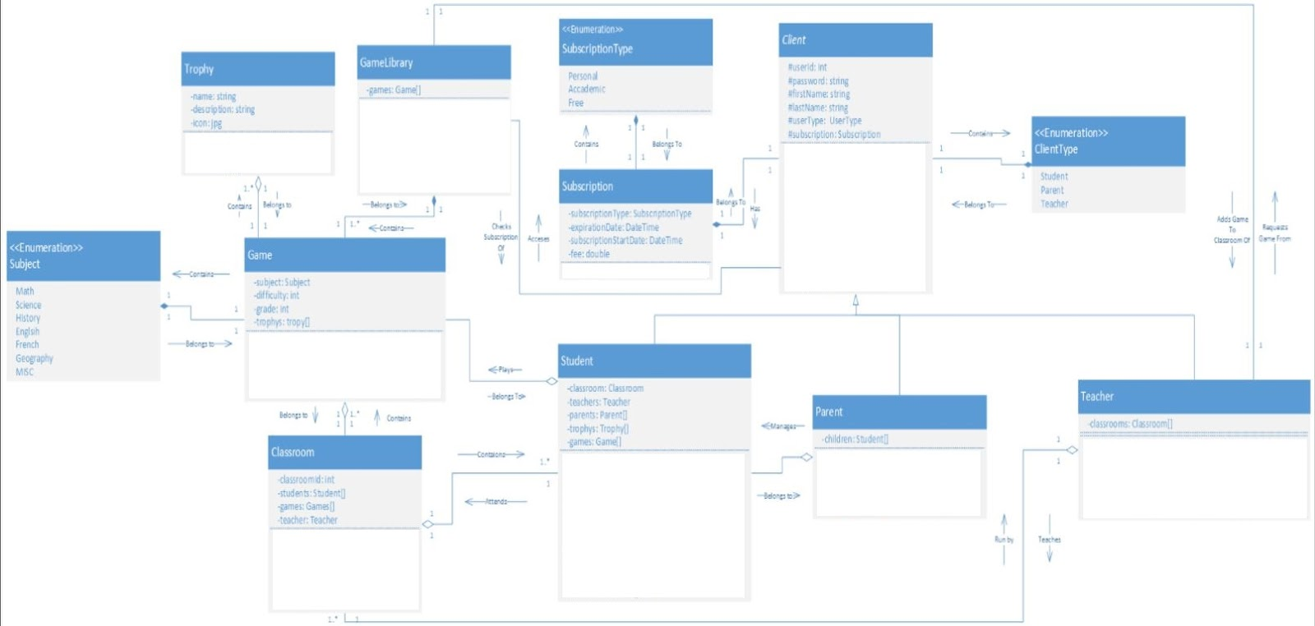

2. CRC Cards

|  |  |
| --- | --- |
| **Class:** Client | |
| Handles clients account creation, login, profile management/profile details, and interactions based on client type. | |
| **Responsibility:** | **Collaborator:** |
| Client account creation. |  |
| Client account login |  |
| Profile management |  |
| Provide interfaces for interaction based on client type (parent/student/teacher) |  |
| Reset password |  |
| Add Subscription | Subscription |
| Cancel Subscription | Subscription |
| Renew subscription | Subscription |

|  |  |
| --- | --- |
| **Class:** Student | |
| This class represents the students who will be using the platform to participates in games and manages personal progress. | |
| **Responsibility:** | **Collaborator:** |
| Review profile information |  |
| View and manage personal progress. | Trophy |
| Interact with Classroom | Classroom |
| Review Games | Game |
| Share Achievement |  |
| Review Trophy | Trophy |
| View Grades |  |
| Play Game | GameLibrary |

|  |  |
| --- | --- |
| **Class:** Parent | |
| This class represents the parents who have control over what games a student can play. | |
| **Responsibility:** | **Collaborator:** |
| Monitor student’s progress. | Student |
| Manage subscriptions. | Subscription |
| View students’ grades | student |
| Change/update student profile information | Student |

|  |  |
| --- | --- |
| **Class:** Teacher | |
| This class represents the professors who might be involved in the assignation of the educational games. | |
| **Responsibility:** | **Collaborator:** |
| Assign games to the classroom | Classroom / Game library |
| Monitor student progress. | Classroom |
| Add students to classroom | Classroom |
| Assign grades |  |
| Create classroom | Classroom |
| Review student’s grades | Classroom |
| Remove students | Classroom |
| Manage subscriptions. | Subscription |

|  |  |
| --- | --- |
| **Class:** Trophy | |
| This class represents the scores achieved and manages the details and achievements of trophies in the game. | |
| **Responsibility:** | **Collaborator:** |
| Store trophy name and description | Game |

|  |  |
| --- | --- |
| **Class:** Game | |
| This class represents the educational games available on the platform. Each game belongs to a specific subject and is appropriate for a specific grade level. | |
| **Responsibility:** | **Collaborator:** |
| Handle student interactions during gameplay. |  |
| Start a game |  |
| End a game |  |
| Award Trophy | Student |

|  |  |
| --- | --- |
| **Class:** Game Library | |
| This class represents the list of the educational games available on the platform. Is the manager to store all the games available. | |
| **Responsibility:** | **Collaborator:** |
| Add a game |  |
| Remove a game |  |
| Update a game |  |
| Add game to the classroom | Teacher |
| Check subscription type before allowing access to a game | Client |

|  |  |
| --- | --- |
| **Class:** Classroom | |
| This class represents the classrooms where students can play games together. Manages a group of students. | |
| **Responsibility:** | **Collaborator:** |
| Assign games to students. | Teacher |
| Add students | Teacher /Students |
| Remove students | Teacher /Students |
| Get students grades | Student |

|  |  |
| --- | --- |
| **Class:** Subscription | |
| Manages the details, renewals, and cancellations of subscriptions. | |
| **Responsibility:** | **Collaborator:** |
| Set the fee for the corresponding subscription type |  |
| Expire on expiration date/re-charge |  |

**3. Domain Class Diagram with methods**

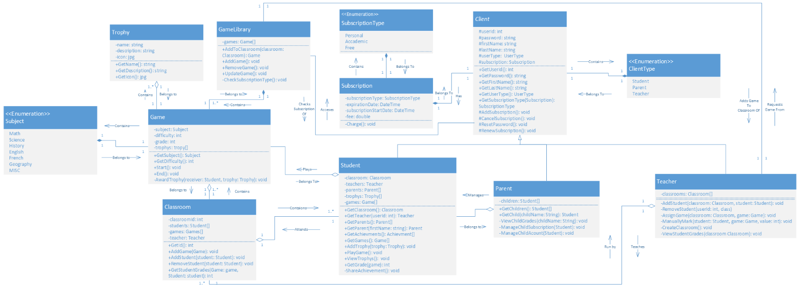

**PART C**

**1. Machine State diagrams**

**GAME CLASS**

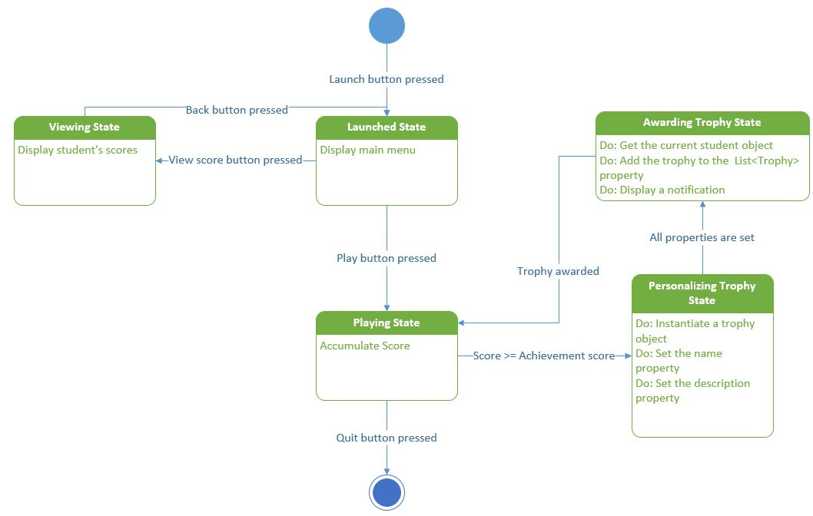

**STUDENT CLASS**

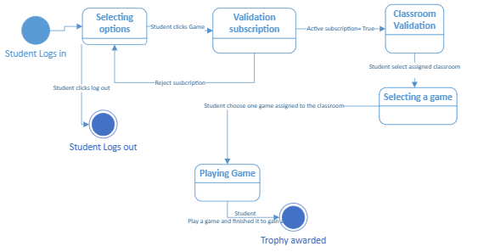

**2. Sequence diagram**

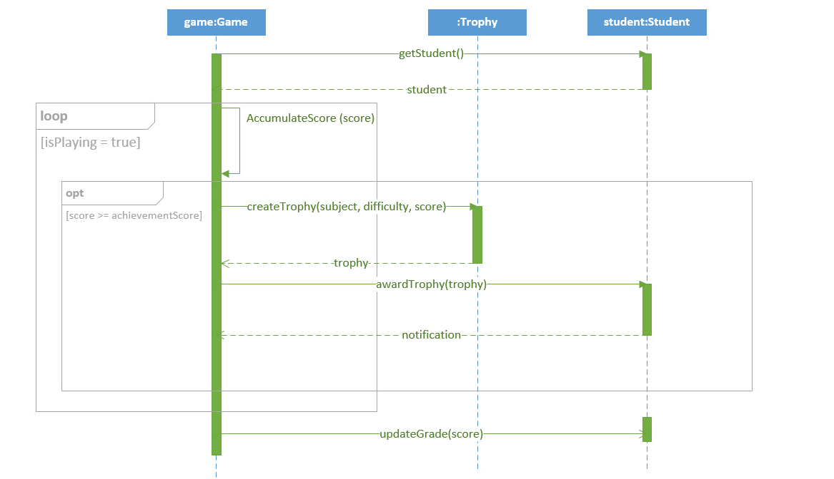

**3. Technical Review**

**Report File Included in the dropbox.**

**4. Party Analysis Patter Research**

The pattern of Accountability is very useful for our project. This is because of various reasons. Firstly, we can use accountability patterns for relationships between the various entities on our website. For example, we can use accountability with the student entity because the student is accountable for completing his/her assignments. It is then the teacher's responsibility to monitor and check these grades. These show that accountability is very useful for most parts of our project.